**Grove - Infrared Receiver**

窗体顶端

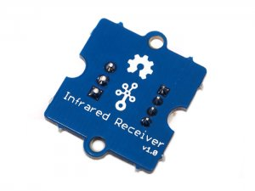

http://www.seeedstudio.com/depot/includes/templates/pure_green/images/next_l.gif

* [http://www.seeedstudio.com/depot/bmz_cache/e/e15a9e29c292b64f1fe257bfbaf6caa1.image.55x55.jpg](http://www.seeedstudio.com/depot/images/product/grerec1.jpg)
* [http://www.seeedstudio.com/depot/bmz_cache/5/58aa4d36c467e54e65582570d9679092.image.55x41.jpg](http://www.seeedstudio.com/depot/images/product/grerec1_01.jpg)

http://www.seeedstudio.com/depot/includes/templates/pure_green/images/next_r.gif

* **Price:**

$3.95  [(Price Feedback)](javascript:void())

* **SKU:**

WLS12136P

* **Weight:**

5Gram

* **Units in Stock**

27

* **Designed by:**

[Seeed Studio](http://www.seeedstudio.com/)



[Other products from designer](http://www.seeedstudio.com/depot/seeed-studio-m-23.html)

* **Quantity:** Max: 27  
  
* [Add to Wish List](http://www.seeedstudio.com/depot/index.php?main_page=un_wishlist&products_id=994&cPath=139_204&action=un_add_wishlist)

Description

The Infrared Receiver is used to receive infrared signals and also used for remote control detection. There is a IR detector on the Infrared Receiver which is used to get the infrared light emitted by the Infrared Emitter. The IR detector have a demodulator inside that looks for modulated IR at 38 KHz. The Infrared Receiver can receive signals well within 10 meters. If more than 10 meters , the receiver may not get the signals. We often use the two Twigs-the Infrared Receiver and the Infrared Emitter to work together.

**Documents**

Please visit our [wiki page](http://www.seeedstudio.com/wiki/Grove_-_Infrared_Receiver) for more info about this product. It will be appreciated if  you can help us improve the documents, add more demo code or tutorials. For technical support, please post your questions to our [forum](http://forum.seeedstudio.com/).

窗体底端